RELG 605
(INTERPRETERS OF ANCIENT ISRAEL)
Metaphor, Myth and Symbol
Genesis 1-11

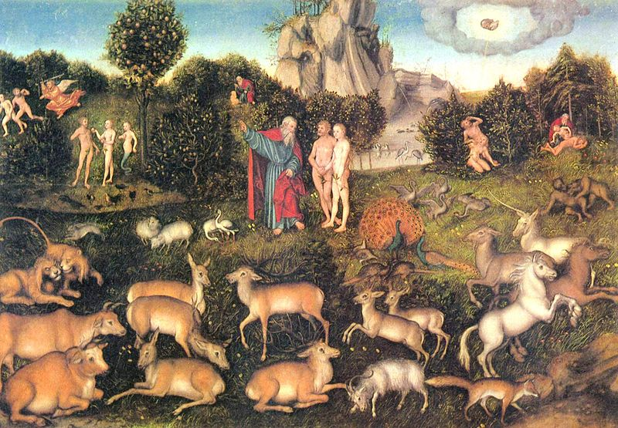

This seminar will apply different close readings to passages from Genesis 1-11 in order to focus on understandings of Metaphor, Myth and Symbol and the hermeneutical problems presented by each of these. The seminar is open to all graduate students interested in the hermeneutical questions associated with these literary categories. Only those graduate students who are registered in the field of Hebrew Bible will be expected to use the MT. All other students will use the text in translation. We will put in to practice what Nietzsche called “the incomparable art of reading well.” This will include various approaches to the text including historical, literary, philosophical, anthropological and theological. By recognizing the many diverse methods of interpretation we will better understand
Wittgenstein’s statement that, “it is possible to be interested in a phenomenon in a variety of ways.”

Professor: Dr. P. G. Kirkpatrick
Place: Rm 105, Henry and William Birk’s building
Time: Tuesdays,12:30-2:30

